Online Shopping System: FOOTFUSION

Use-Case Specification: View Payment Methods

Version <1.0>

Revision History
Date | Version | Description | Author
<25/11/2024> | <1.0> | Final Draft | Vũ Trí Nguyện

Table of Contents
1. Use-Case Name 4
1.1 Brief Description 4
2. Flow of Events 4
2.1 Basic Flow 4
2.2 Alternative Flows 4
2.2.1 < First Alternative Flow > 4
2.2.2 < Second Alternative Flow > 5
3. Special Requirements 5
3.1 < First Special Requirement > 5
4. Preconditions 5
4.1 < Precondition One > 5
5. Postconditions 5
5.1 < Postcondition One > 5
6. Extension Points 5
6.1 <Name of Extension Point> 5

Use-Case Specification: View Payment Methods

Use-Case Name

Brief Description
This use case defines the steps of displaying new payment methods. It contains the payment methods in the database system and displays exactly that method on the list.

Actor
FootFusion administrator.

Flow of Events

Basic Flow
Administrator logs into the FootFusion admin panel. The administrator navigates to the "Payment Methods" section. The administrator selects the payment method they wish to update from the list displayed on the table. The administrator clicks on the “Edit” icon next to the selected payment method. The system navigates the administrator to the edit page, where they can modify details such as payment method name, fees, and availability. After filling in the necessary updates, the administrator clicks the “Save changes” button. The system automatically updates the payment method information in the database and refreshes the table to display the updated information.

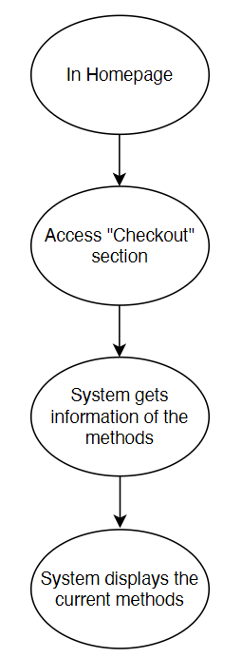

Alternative Flows
None.

Special Requirements
The administrator must have basic knowledge of operating computers and user interfaces.

Preconditions
The administrator is logged in and has at least one payment method available to edit.

Postconditions
The updated payment method information is saved to the database and displayed on the Manage Payment Methods page in FootFusion.

Extension Points
There is no extension point.

Prototype
Figure 1: To view methods, the system will click on Checkout screen and in the “Payment” section
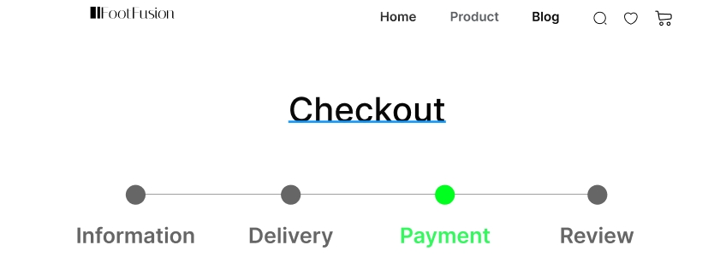

Figure 2: In Payment Method section, users can view all the methods they can choose to pay
